Tec Nano 2019

Effect of Mechanical Compression Pre-pyrolysis on the Electrical Conductivity of SU-8-derived Carbon Materials

Saeed Beigi-Boroujeni1, Osamu Katagiri-Tanaka1, Alan Aguirre-Soto[1],*

1School of Engineering and Sciences, Tecnologico de Monterrey, Av. Eugenio Garza Sada Sur, Monterrey, 2501, N.L., Mexico.

Abstract

The so-called SU-8 formulation was originally designed as a negative photoresist alternative but has now become the gold standard in the fabrication of micro-electromechanical systems (MEMS) due, in great part, to the electrical conductivity obtained after carbonization of the Bis-Phenol A Novolac Epoxy (BPNE) oligomer contained therein. Here, we investigated the possibility of increasing the electrical conductivity by mechanical compression pre-pyrolysis. BPNE sheets were casted, compressed and photo-crosslinked to “freeze” the material in a strained configuration before pyrolysis. The electrical conductivity was then measured using the four-point-probe method. The extent of graphitization and the degree of crystallinity were determined by XRD and Raman Spectroscopy, respectively. It was hypothesized that applying compressive loads of up to 2000 kg would increase the volume fraction of crystalline domains by inducing further alignment of the aromatic segments within the bisphenolic core. However, no significant variations in conductivity, crystallinity and sp2 carbon content were detected between compressed and standard SU-8 films, suggesting higher loads or temperatures may be required to further induce graphitization.

[copyright information to be updated in production process]

*Keywords: SU-8 photoresist; Epoxy oligomer; Cationic photopolymerization; Stress-induced graphitization; Pyrolysis; Carbon materials;*

1. Introduction

Carbon materials rich in graphitic domains have attracted a great deal of attention in a wide variety of applications thanks to their inertness, high electrical conductivity, stiffness, excellent optical transparency perpendicular to the transmitted light, and electrochemical stability [1–8]. In particular, the high electrical conductivity of carbon materials has made them popular as potential candidates to replace silicon in electronics: sensors, batteries, supercapacitors, and transistors [9–11]. As a result, since the turn of the last Century, a substantial amount of research has been dedicated to the investigation of methods to increase the electrical conductivity of carbon materials derived from organic polymer precursors at reasonable costs. From these studies, it is interesting to note that some of the most promising carbon materials are derived from synthetic organic polymer precursors and through appropriate tuning of the pyrolysis protocol as a function of the macromolecular structure of the carbon source.

The pyrolysis of organic polymers has been subject of investigation for the fabrication of carbon materials with the hope to find the ideal combination of polymer and pyrolysis protocol to increase the sp2 carbon content or simply to learn how to obtain various degrees of particularly desired carbon allotropes within a material. A myriad of polymer precursors have been tested since the seminal crystallinity studies from the mid-20th Century, where various temperatures and atmospheres, or lack thereof, where analyzed in terms of their impact on the final microstructure of the carbon material [12].

More recently, the so-called SU-8 resin formulation, which was originally developed as a negative UV photoresist that can yield high-transparency coatings after photopolymerization, has turned into one of the most popular precursors for the fabrication of electrically conductive carbon materials with outstanding aspect ratios. Yet, the precise mechanism of how this formulation is capable of achieving such outstanding microscopic aspect ratios for carbon micro-electromechanical systems remains unclear. The SU-8 formulation contains an oligomer, Bis-phenol A Novolac Epoxy (BPNE), with a structure based on a number (n) of bisphenol units with (2n) pendant epoxy groups that can undergo cationic polymerization upon production of an acid by an appropriate initiator, whether it is activated by thermal or electromagnetic energy, to produce a highly cross-linked material by ring-opening the epoxy groups. Most often, the photoinitiator (PI) found in these formulations is a sulfonium salt, where cyclopentanone is utilized as the solvent to allow fast casting of the oligomer and photoinitiator (Figure 1) [12–14]. The cyclopentanone, required to adjust initial viscosity and facilitate manipulation of the solid-state oligomer, is mostly evaporated in the casting or electrospinning steps. Therefore, we will refer to our precursor material as simply Bis-phenol A Novolac Epoxy (BPNE) considering that the other left-over molecules from the SU-8 formulation, PI and salt additives, are present in relatively low quantities and not expected to greatly affect the properties of the final pyrolyzed materials.

Since carbon materials can vary greatly in the volume fractions of crystalline and amorphous regions, their electronic properties have been documented to change frequently and often dramatically as a function of the precursor and fabrication conditions. Recently, different chemical and physical methods have been applied to increase the extent of graphitization and enhance the electronic and chemical properties of these materials [14–17]. Inspired by these studies, we decided to test the possibility of increasing the electrical conductivity of the carbon materials derived from the pyrolysis of BNPE as a function of the application of a mechanical stress, namely compression, since it is a relatively simple and cost-effective method to increase the crystallinity of polymer precursors before pyrolysis. The latter, given the possibility of going above the melting temperature (Tm) of the uncured epoxy oligomer and using a compressive force to induce the formation of more crystalline domains in the material.

Others have successfully employed the idea of mechanically compressing the polymer precursors before pyrolysis to increase the crystallinity of the final carbon material and thus the electrical conductivity. Ghazinejad et al. [17] investigated the effect of compression and tension on the degree of graphitization and molecular alignment of poly-acrylonitrile (PAN) fibers. An electrospinning process was used to unwind and orient the molecular chains via electrohydrodynamic forces in far-field electrospinning with and without carbon nanotubes as templating agents. The stabilized PAN fibers were then pyrolyzed for samples with and without the mechanical strain in compression and tension modes, where thermal crosslinking was employed to lock the polymer into a network configuration. Their results show that with the correct combination of thermal crosslinking and mechanical stress, the previously “un-graphitizable” PAN can be converted into a carbon material with a noticeably higher sp2-hybridized carbon content and good electrical conductivity via a stress-induced route. This motivated the present investigation of the possibility of enhancing the electrical conductivity of other materials, i.e. Bis-Phenol A Novolac Epoxy, with a combination of photo-crosslinking and compression to increase its electrical conductivity after pyrolysis beyond the current limits.

Cardenas-Benitez et al. [12] proposed that mechanical forces during the pyrolysis of photocured BPNE-derived structures, evidence by their shrinkage, contribute towards increasing the electrical conductivity of the final carbon materials. The study showed that the structures shrank about 70% of their original size. The shrinkage and elongation of suspended BPNE fibers during pyrolysis appears to have influenced the final electrical properties [14]. Canton et al. [14] deposited BPNE fibers over BPNE posts to form monolithic micro-structures. As the walls shrink during pyrolysis, shrinkage-induced internal forces result in the elongation of the suspended fibers. Evidence appears to suggest that the electrical conductivity increases when fibers are elongated and stretched as their diameter decrease due to internal forces during free volume loss [14]. These observations additionally guided us in stipulating that one could increase the crystallinity of BPNE-derived carbon materials by compressing them before pyrolysis. However, it is reasonable to expect that proving this hypothesis through a compressive mechanical test for the previously used suspended nanowires will be a remarkable experimental challenge considering the dimensions and the precision that one must have in straining the material at such scales.

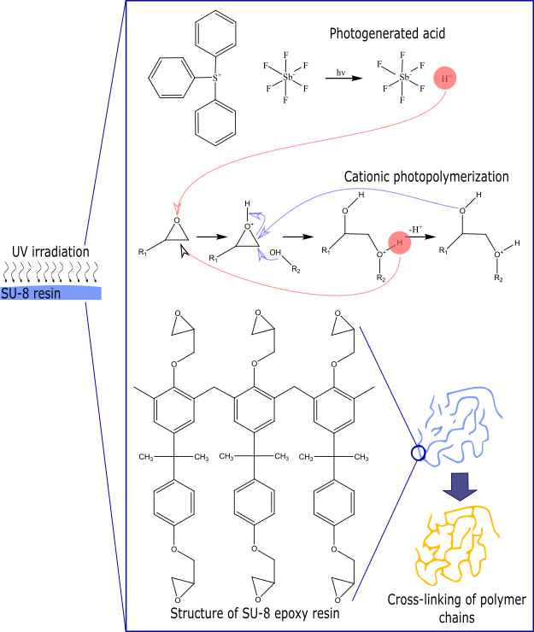

Fig. 1. Cationic photo-crosslinking of Bis-phenol A Novolac Epoxy contained in the SU-8 formulation upon exposure to 365 nm light.

On the other hand, the electrical conductivity of carbon electrodes has been shown to improve upon the application of mechanical stresses and proposed to be due to an increase in the alignment of the polymer linear segments within the fibers, i.e. a type of templating mechanism, such as that employed in the electrospinning with carbon nanotubes and graphene sheets. Recent studies showed that the electrical conductivity of carbon electrodes is enhanced after pyrolysis, as the precursor polymer chains align within the fibers yielding carbon structures with enhanced quality and crystallinity as a result of the internal mechanical stresses that develop during pyrolysis [18,19]. The use of carbon nanotubes, for instance, [16,17,20] in combination with hydro-electromechanical strain via electrospinning processes, appears to result in the alignment of polymer chains, leading to the production of carbon fibers with superior electrical conductivity, which is now a classical example of the use of a templating mechanism to align polymer chains along an axis [21].

Here, we aimed at investigating if the electrical conductivity of the carbon materials formed after pyrolysis of photo-crosslinked Bis-phenol A Novolac Epoxy oligomer can be increased by mechanically compressing BPNE sheets before the photo-crosslinking and pyrolysis steps. The aim of this paper is to evaluate whether the correlation between mechanical straining and final electrical conductivity of BPNE-derived carbon materials can be proven on such macroscopic thin film samples. The overarching goal is to find methods to produce carbon materials from polymer precursors yielding higher electrical conductivity and mechanical strength by matching the fabrication conditions to the particular organic polymer selected and its molecular structure. The present study serves as a first attempt to demonstrate if mechanical compression and photo-crosslinking of the epoxy oligomers before pyrolysis can be reliably used to produce higher conductivity materials and attempt to obtain insights into the uniqueness of the BPNE chemistry for the fabrication of MEMS.

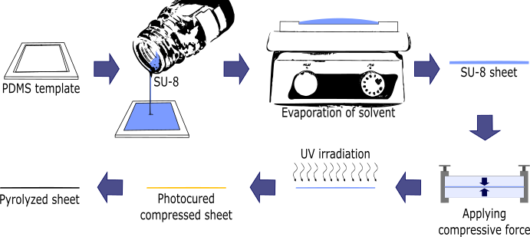

Fig. 2. Schematic diagram of the fabrication process for samples.

1. Materials and Methods
   1. Casting, photo-crosslinking and pyrolysis of Bis-phenol A Novolac Epoxy sheets

The SU-8 2100 formulation was purchased from MicroChem Corp. (now Kayaku Advanced Materials, Westborough, MA, USA) and used as received according to the thin sheet casting protocol below. A poly-dimethyl siloxane (PDMS) soft-lithography kit (Sylgard 184, Dow Chemical Company, USA) was purchased and used without any modification and according to the manufacturer instructions to fabricate molds for the casting of the SU-8 sheets.

Compressed samples were fabricated according to the steps described in Figure 2. The SU-8 2100 formulation was casted and utilized after evaporation of the cyclopentanone by increasing the temperature to 75 °C for 4h using a standard hot-plate. The pre-heated SU-8 sheets were compressed by applying a constant load of up to 2000 kg for 30 minutes to yield a maximum compressive stress of around 50 MPa. The compressed samples were immediately exposed 365 nm light in a UV chamber (DYMAX 2000-EC equipped with a halogen bulb with an intensity of approximately 105 mW/cm2). Photo-polymerized samples with and without the compression step were subsequently pyrolyzed at 1000 °C under N2 atmosphere. Control samples were fabricated without applying the mechanical compressive force and without exposure to the UV light for comparison.

The samples were pyrolyzed in a furnace (PEO 601, ATV Technologie GmbH, Germany) according to the following temperature profile: (1) the temperature was increased from room temperature to 300°C at a heating rate of 30°C/min, (2) temperature was kept at 300 °C for 3hours, (3) the temperature was ramped to 900°C at 10°C/min and kept for 1hour, and (4) the temperature was brought back to room temperature at 30°C/min.

* 1. XRD and Raman spectroscopy

X-ray diffraction (XRD) patterns were obtained for all samples recording over a 2θ in the range of 5-55° using a spectrometer (Miniflex 600, Rigaku, USA) equipped with the Cu Kα radiation source.

Analysis of the sp2-hybridized carbon content was carried out using a Raman spectrometer (Bruker, USA) equipped with a 532 nm laser. The Raman maps and the averaged Raman spectra were collected across 25 µm2 tiles.

* 1. Electrical conductivity measurements

The conductivity of samples was measured using the four-point-probe method. Four electrical probes were placed in contact with the surface of the casted thin sheets. The current is applied through the sample from the outer two probes and the voltage drop is measured by the inner two probes [22]. In very thin samples, the resistivity is calculated using the following equation (1):

Where, V is the voltage, I is the applied current, and t is the thickness of the thin sample sheet. The thickness was adjusted to 0.5 mm for all samples. The control samples were casted in a different mold to yield a comparable thickness. The other samples were casted in different molds with higher thickness (1.5 mm) and after applying compressive force, the thickness turned to 0.5 mm. The current was changed between 0 and 1.5 amperes.

1. Results and discussion

Since the electrical conductivity is well known to correlate with the extent of graphitization and it is our target property, we began by measuring the conductivity using the four-point probe method for all the BPNE sheets with and without compression. We measured a resistivity of around 0.018 (Fig. 3) for the pyrolyzed sheets both with and without compression before pyrolysis. Our values are comparable to the previously reported values for carbon materials derived from the pyrolysis of BPNE casted into different geometries. Pramanick et al[1], reported that the resistivity of pyrolyzed SU-8-derived samples oscillated around 5-10 once a maximum temperature of 700 or higher is reached in the pyrolysis protocol. Therefore, our measurements appeared to give reasonable values despite the sample geometry and the surface roughness that was obtained in the pyrolyzed sheets due to the compression. These results give a conductivity of around 53 S/cm, which is relatively low compared to other pyrolyzed organic polymer precursors and previously reported values for BPNE-derived carbon materials [12]. However, discrepancies may stem from inaccuracies in the electrical conductivity measurements depending on the geometry and size of the final carbon material.

We observe a negligible difference in the resistivity values for the samples that were compressed before photo-crosslinking as compared to the samples that were photo-crosslinked and pyrolyzed without mechanical compression. Attention was paid to make the BPNE sheets of approximately the same final thickness for both sets of samples. At least three samples were tested for every group. This result appears to indicate that there is no increase in electrical conductivity correlated to the use of compression before pyrolysis. However, it is possible that surface roughness and irregularities in the BPNE thin sheets after pyrolysis lead to poor precision in the four-point-probe measurements. Therefore, we decided to further characterize the variations in the structure of the samples through the analytical methods discussed below to further investigate whether there is indeed an absence of significant variations in the properties of BPNE-derived carbon materials with and without the compressive pre-treatment.

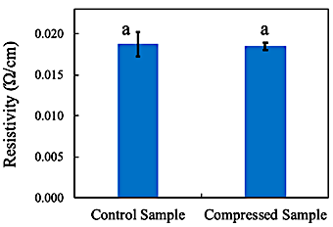

Fig. 3. Average resistivity of pyrolyzed Bis-phenol A Novolac Epoxy casted into thin sheets with and without compression (p > 0.05a ANOVA).

Given our hypothesis and the suspicion that the four-point probe method may not be ideal to quantify small variations in electrical conductivity in the pyrolyzed thin sheets that were obtained in this study, we investigated the Raman spectra of the pyrolyzed samples. The uniformity of graphite crystallites can be evaluated by Raman Spectroscopy. Figure 4 shows the average Raman spectra of different samples. There are two characteristic peaks at 1367 and 1600 cm-1 assigned to the D and G bands, respectively. The G peak arises from the stretching motion of the sp2-hybridized carbon-carbon bond in graphitic materials and D peak corresponds to the disorder structure. The intensity ratio of D peak to G peak is used for evaluation the degree of graphitization. Hence, the higher the D to G ratio, the lower the alignment of graphitic planes is, thereby lowering the degree of graphitization in the carbon structure [23]. As it can be seen in Figure 4, the intensity of the peaks is the same, yielding an ID/IG ratio that is close to 1, coinciding with the graphite crystallite size and the degree of disorder obtained previously for pyrolyzed organic polymers. In comparison, compressive stress treatment of poly-acrylonitrile (PAN) with carbon nanotubes as templating agents yielded an ID/IG ratio of 0.69 [17]. Most importantly, we observe that the mechanical compressive treatment does not appear to have a significant effect on the microstructure of the pyrolyzed sheets with and without compression, which may be related to mechanical properties of the starting polymer before the mechanical treatment.

Furthermore, the 2D maps from the Raman spectroscopy analysis of pyrolyzed BPNE-derived sheets with and without compression is depicted in Figure 4. We focused on the same bands discussed above, which are associated to graphitic domains, and observed that in both cases the surface appears to be highly uniform in terms of its carbon allotropes. These results suggest that there is a significantly uniform graphitization microstructures in both cases and that the surface is smooth at least microscopically in the cross-section area analyzed on the pyrolyzed sheets. These observations agree with the seemingly constant electrical conductivity that we quantified with the four-point probe method and appear to be suggesting that indeed higher temperatures and mechanical loads may be required to induce further alignment of the phenolic segments within the material before crosslinking.

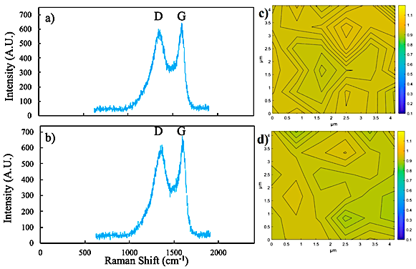

Figure 4. Analysis of carbon content in pyrolyzed Bis-phenol A Novolac Epoxy sheets a) without and b) with compression before pyrolysis. 2D Raman analysis of the pyrolyzed films c) without compression and d) with compression.

In order to obtain a confirmation for the lack of correlation between the compression and the properties of the pyrolyzed BPNE-derived sheets, as per the resistivity measurements and the Raman spectroscopy analysis, we employed X-ray diffraction (XRD) spectroscopy to try to discern if there were any variations present between the two sets of samples, in terms of their crystallinity. The results are shown in Figure 5. Two broad diffraction peaks can be observed in both the samples, in 22° and 55°. The broad bands at 22° and 55 are related to (002) plane and (100) plane respectively [24]. The broadness of these peaks appears to be correlated with poor stacking of the graphene layers in the (002) and (100) planes. This is similar to previous XRD spectra of similar glassy-carbon materials, where the mesoscale structure resembles that of semi-crystalline organic polymer networks. Most importantly, we observe no noticeable differences between the XRD spectra for the BPNE-derived sheets with and without compression. Thus, we can establish that this third evidence further supports the lack of contribution of the compressive stress of the BPNE thin sheets on their microstructure and on the electrical properties stemming therefrom.

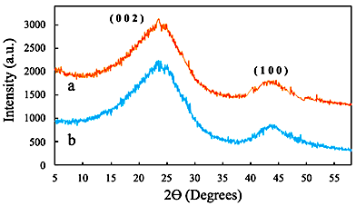

Figure 5. Crystallinity of Bis-phenol A Novolac Epoxy thin sheets a) without and b) with compression before pyrolysis from their X-Ray diffraction (XRD) patterns.

Although mechanical stresses had been successfully employed to increase the crystallinity of polyacrylonitrile (PAN) and therefore the extent of graphitization and conductivity of the final carbon materials therefrom [17], it seems that the highly-strained microscopic configuration and orientation of graphite crystallites within a relatively amorphous crosslinked carbon network make it difficult to induce further alignment in these materials. This may indicate that if the electrical conductivity of BPNE-derived carbonaceous materials can be enhanced at all, this will require higher temperatures and pressures to have an effect in the microstructure after pyrolysis. It is still possible that the previously observed increase in the electrical conductivity of suspended nanowires is related, at least in part, to the mechanical stresses that develop during pyrolysis. However, in this case, it can be hypothesized that the stress per unit mass must then be higher than the ones reached in this study, especially as a result of the shrinkage from the gasification of the ether linkages in the bisphenolic groups within the polymer network. Therefore, it is suggested to further explore the validity of this hypothesis by carefully designing experiments were mechanical stresses are applied on other types of geometries and sizes of casted BPNE samples that are more susceptible to the application of higher compressive or tensile forces before photo-crosslinking.

1. Conclusion

In this study, we tested the hypothesis that the microstructure and the electrical conductivity of carbon materials derived from the pyrolysis of Bis-phenol A Novolac Epoxy can be increased by mechanical compression pre-pyrolysis using millimeter scale thin sheets. First, measurements of the resistivity indicated that there is a negligible variation of the electrical macroscopic properties with the compression pre-treatment. Then, Raman spectroscopy and XRD supported the finding that there does not seem to be any significant variations in the graphitic crystallite size and order, or in the crystallinity between the samples with and without compression of up to 50 MPa, respectively. We cannot conclude from this study if the electrical properties of BPNE-derived carbon materials can be at all enhanced by modifying the fabrication protocol with mechanical forces. The latter was at least not possible with the fabrication process used herein. However, it appears that if mechanical deformation resulting from the pyrolysis of bis-phenolic epoxy precursors takes part in the previously documented increase in electrical conductivity due to internal stresses from the pyrolysis itself, the stresses therein must be considerable higher to result in the alignment of the phenolic cores and induce a higher degree of order through π-π stacking that may lead a higher-conductivity glass-like carbon material. The goal is that this study serves as starting point in the search of relatively low-cost methods to obtain high-electrical-conductivity carbon materials from organic polymer precursors that can be easily patterned into functional geometries.

Acknowledgements

We thank Prof. Dr. Marcelo Videa for use of the XRD spectrometer and Dr. Sunny Holmberg for help with the Raman spectroscopy measurements of the pyrolyzed BPNE sheets. We thank Dr. Arnoldo Sanchez for guidance with the four-point-probe method. We thank the support of a China-Tec from Tecnologico de Monterrey seed-fund for the development of 2D photosensitive materials.

# Nomenclature

BPNE Bis-phenol A Novolac Epoxy

PDMS Poly-dimethylsiloxane

PAN Poly-acrylonitrile

MEMS Micro-electromechanical systems

XRD X-ray diffraction

UV Ultraviolet

References

[1] R.L. McCreery, Advanced Carbon Electrode Materials for Molecular Electrochemistry, Chem. Rev. 108 (2008) 2646–2687.

[2] A.K. Geim, Random Walk to Graphene (Nobel Lecture), Angew. Chemie Int. Ed. 50 (2011) 6966–6985.

[3] M.J. Allen, V.C. Tung, R.B. Kaner, Honeycomb Carbon: A Review of Graphene, Chem. Rev. 110 (2010) 132–145.

[4] Y. Zhu, S. Murali, W. Cai, X. Li, J.W. Suk, J.R. Potts, R.S. Ruoff, Graphene and Graphene Oxide: Synthesis, Properties, and Applications, Adv. Mater. 22 (2010) 3906–3924.

[5] M.. Katsnelson, A.. Geim, Electron scattering on microscopic corrugations in graphene, Philos. Trans. R. Soc. A Math. Phys. Eng. Sci. 366 (2008) 195–204.

[6] D. Li, R.B. Kaner, MATERIALS SCIENCE: Graphene-Based Materials, Science (80-. ). 320 (2008) 1170–1171.

[7] A.K. Geim, K.S. Novoselov, The rise of graphene, Nat. Mater. 6 (2007) 183–191.

[8] A.K. Geim, Graphene: Status and Prospects, Science (80-. ). 324 (2009) 1530–1534.

[9] H.C. Schniepp, J.-L. Li, M.J. McAllister, H. Sai, M. Herrera-Alonso, D.H. Adamson, R.K. Prud’homme, R. Car, D.A. Saville, I.A. Aksay, Functionalized Single Graphene Sheets Derived from Splitting Graphite Oxide, J. Phys. Chem. B. 110 (2006) 8535–8539.

[10] H.C. Schniepp, K.N. Kudin, J.-L. Li, R.K. Prud’homme, R. Car, D.A. Saville, I.A. Aksay, Bending Properties of Single Functionalized Graphene Sheets Probed by Atomic Force Microscopy, ACS Nano. 2 (2008) 2577–2584.

[11] M.F. El-Kady, V. Strong, S. Dubin, R.B. Kaner, Laser Scribing of High-Performance and Flexible Graphene-Based Electrochemical Capacitors, Science (80-. ). 335 (2012) 1326–1330.

[12] B. Cardenas-Benitez, C. Eschenbaum, D. Mager, J.G. Korvink, M.J. Madou, U. Lemmer, I. De Leon, S.O. Martinez-Chapa, Pyrolysis-induced shrinking of three-dimensional structures fabricated by two-photon polymerization: experiment and theoretical model, Microsystems Nanoeng. 5 (2019).

[13] B.Y. Park, L. Taherabadi, C. Wang, J. Zoval, M.J. Madou, Electrical Properties and Shrinkage of Carbonized Photoresist Films and the Implications for Carbon Microelectromechanical Systems Devices in Conductive Media, J. Electrochem. Soc. 152 (2005) J136.

[14] G. Canton, T. Do, L. Kulinsky, M. Madou, Improved conductivity of suspended carbon fibers through integration of C-MEMS and Electro-Mechanical Spinning technologies, Carbon N. Y. 71 (2014) 338–342.

[15] N. Liu, K. Kim, H.Y. Jeong, P.C. Hsu, Y. Cui, Z. Bao, Effect of Chemical Structure on Polymer-Templated Growth of Graphitic Nanoribbons, ACS Nano. 9 (2015) 9043–9049.

[16] A. Allaoui, S.V. Hoa, M.D. Pugh, The electronic transport properties and microstructure of carbon nanofiber/epoxy composites, Compos. Sci. Technol. 68 (2008) 410–416.

[17] M. Ghazinejad, S. Holmberg, O. Pilloni, L. Oropeza-Ramos, M. Madou, Graphitizing Non-graphitizable Carbons by Stress-induced Routes, Sci. Rep. 7 (2017) 16551.

[18] T. Maitra, S. Sharma, A. Srivastava, Y.K. Cho, M. Madou, A. Sharma, Improved graphitization and electrical conductivity of suspended carbon nanofibers derived from carbon nanotube/polyacrylonitrile composites by directed electrospinning, Carbon N. Y. 50 (2012) 1753–1761.

[19] D. Mattia, M.P. Rossi, B.M. Kim, G. Korneva, H.H. Bau, Y. Gogotsi, Effect of Graphitization on the Wettability and Electrical Conductivity of CVD-Carbon Nanotubes and Films, J. Phys. Chem. B. 110 (2006) 9850–9855.

[20] S. Holmberg, M. Ghazinejad, E. Cho, D. George, B. Pollack, A. Perebikovsky, R. Ragan, M. Madou, Stress-activated pyrolytic carbon nanofibers for electrochemical platforms, Electrochim. Acta. 290 (2018) 639–648.

[21] M. Yoonessi, J.R. Gaier, M. Sahimi, T.L. Daulton, R.B. Kaner, M.A. Meador, Fabrication of Graphene–Polyimide Nanocomposites with Superior Electrical Conductivity, ACS Appl. Mater. Interfaces. 9 (2017) 43230–43238.

[22] B. Xue, Y. Zou, Y. Yang, A photochemical approach for preparing graphene and fabrication of SU-8/graphene composite conductive micropatterns, Mater. Des. 132 (2017) 505–511.

[23] Y.M. Hassan, C. Caviglia, S. Hemanth, D.M.A. Mackenzie, T.S. Alstrøm, D.H. Petersen, S.S. Keller, High temperature SU-8 pyrolysis for fabrication of carbon electrodes, J. Anal. Appl. Pyrolysis. 125 (2017) 91–99.

[24] S. Mamidi, M. Kakunuri, C.S. Sharma, Fabrication of SU-8 Derived Three-Dimensional Carbon Microelectrodes as High Capacity Anodes for Lithium-Ion Batteries, ECS Trans. 85 (2018) 21–27.

1. * Corresponding author. Tel.: +52 1 81 11706549.

   *E-mail address:* alan.aguirre@tec.mx